AGRSoft POS System – Project Documentation

Overview
AGRSoft POS is a complete, cross-platform Point of Sale (POS) solution designed for mobile, tablet, and desktop devices. It supports both online and offline operations with automatic data synchronization when internet connectivity is restored.

Core Features

1. Offline & Online Functionality
- Fully functional without internet
- Automatic data sync when connection is restored
- No data loss during downtime

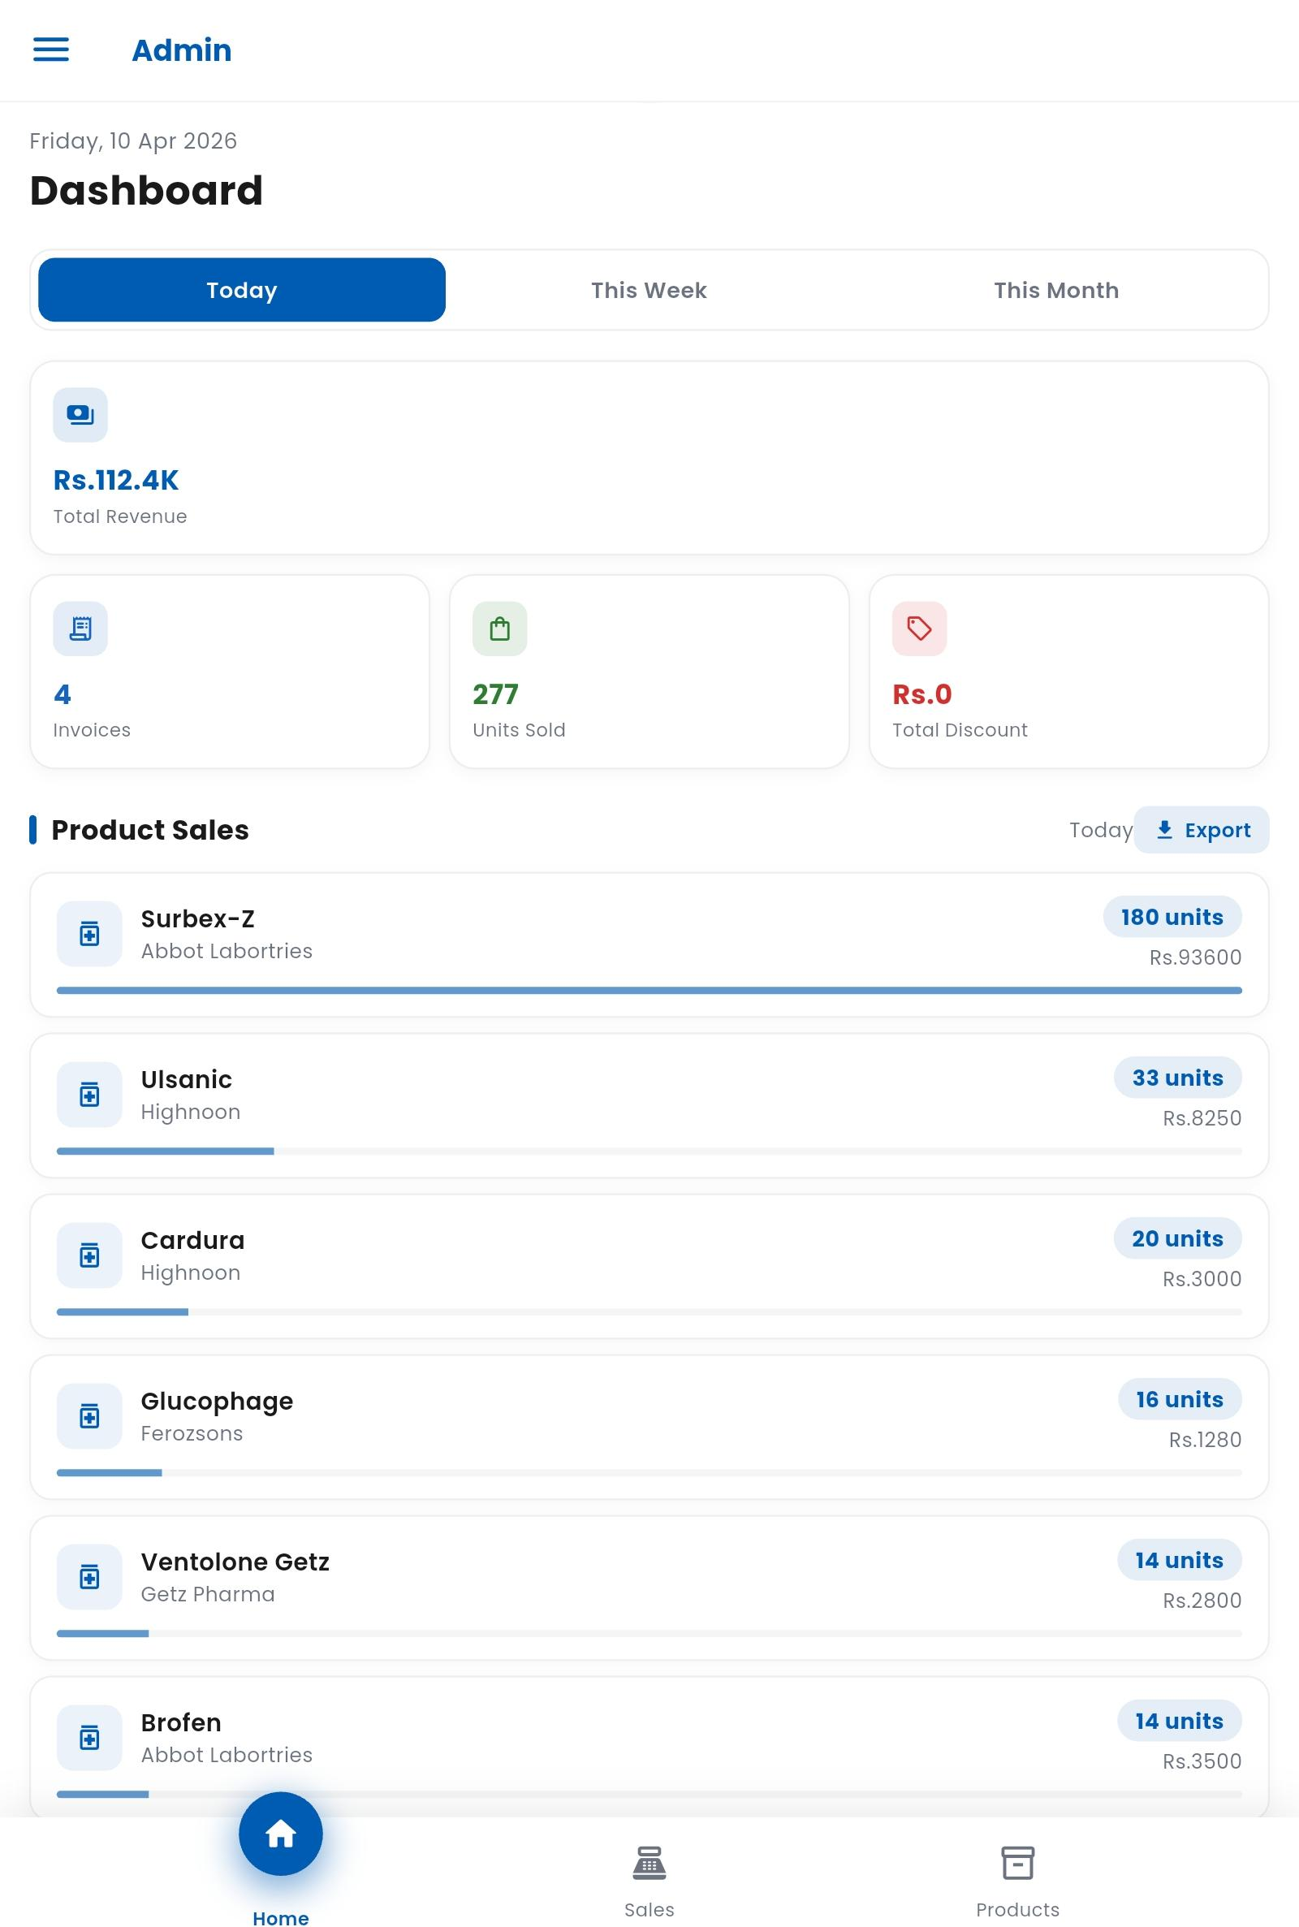

2. Product & Inventory Management
- Add, update, and delete products
- Barcode and batch number support
- Inventory tracking:
  - Total stock
  - Low stock alerts
  - Out-of-stock alerts
  - Expiry alerts
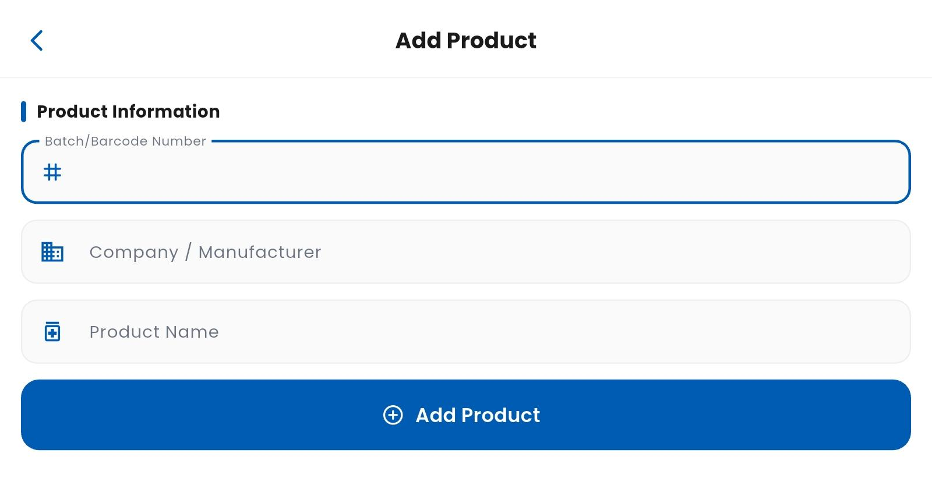
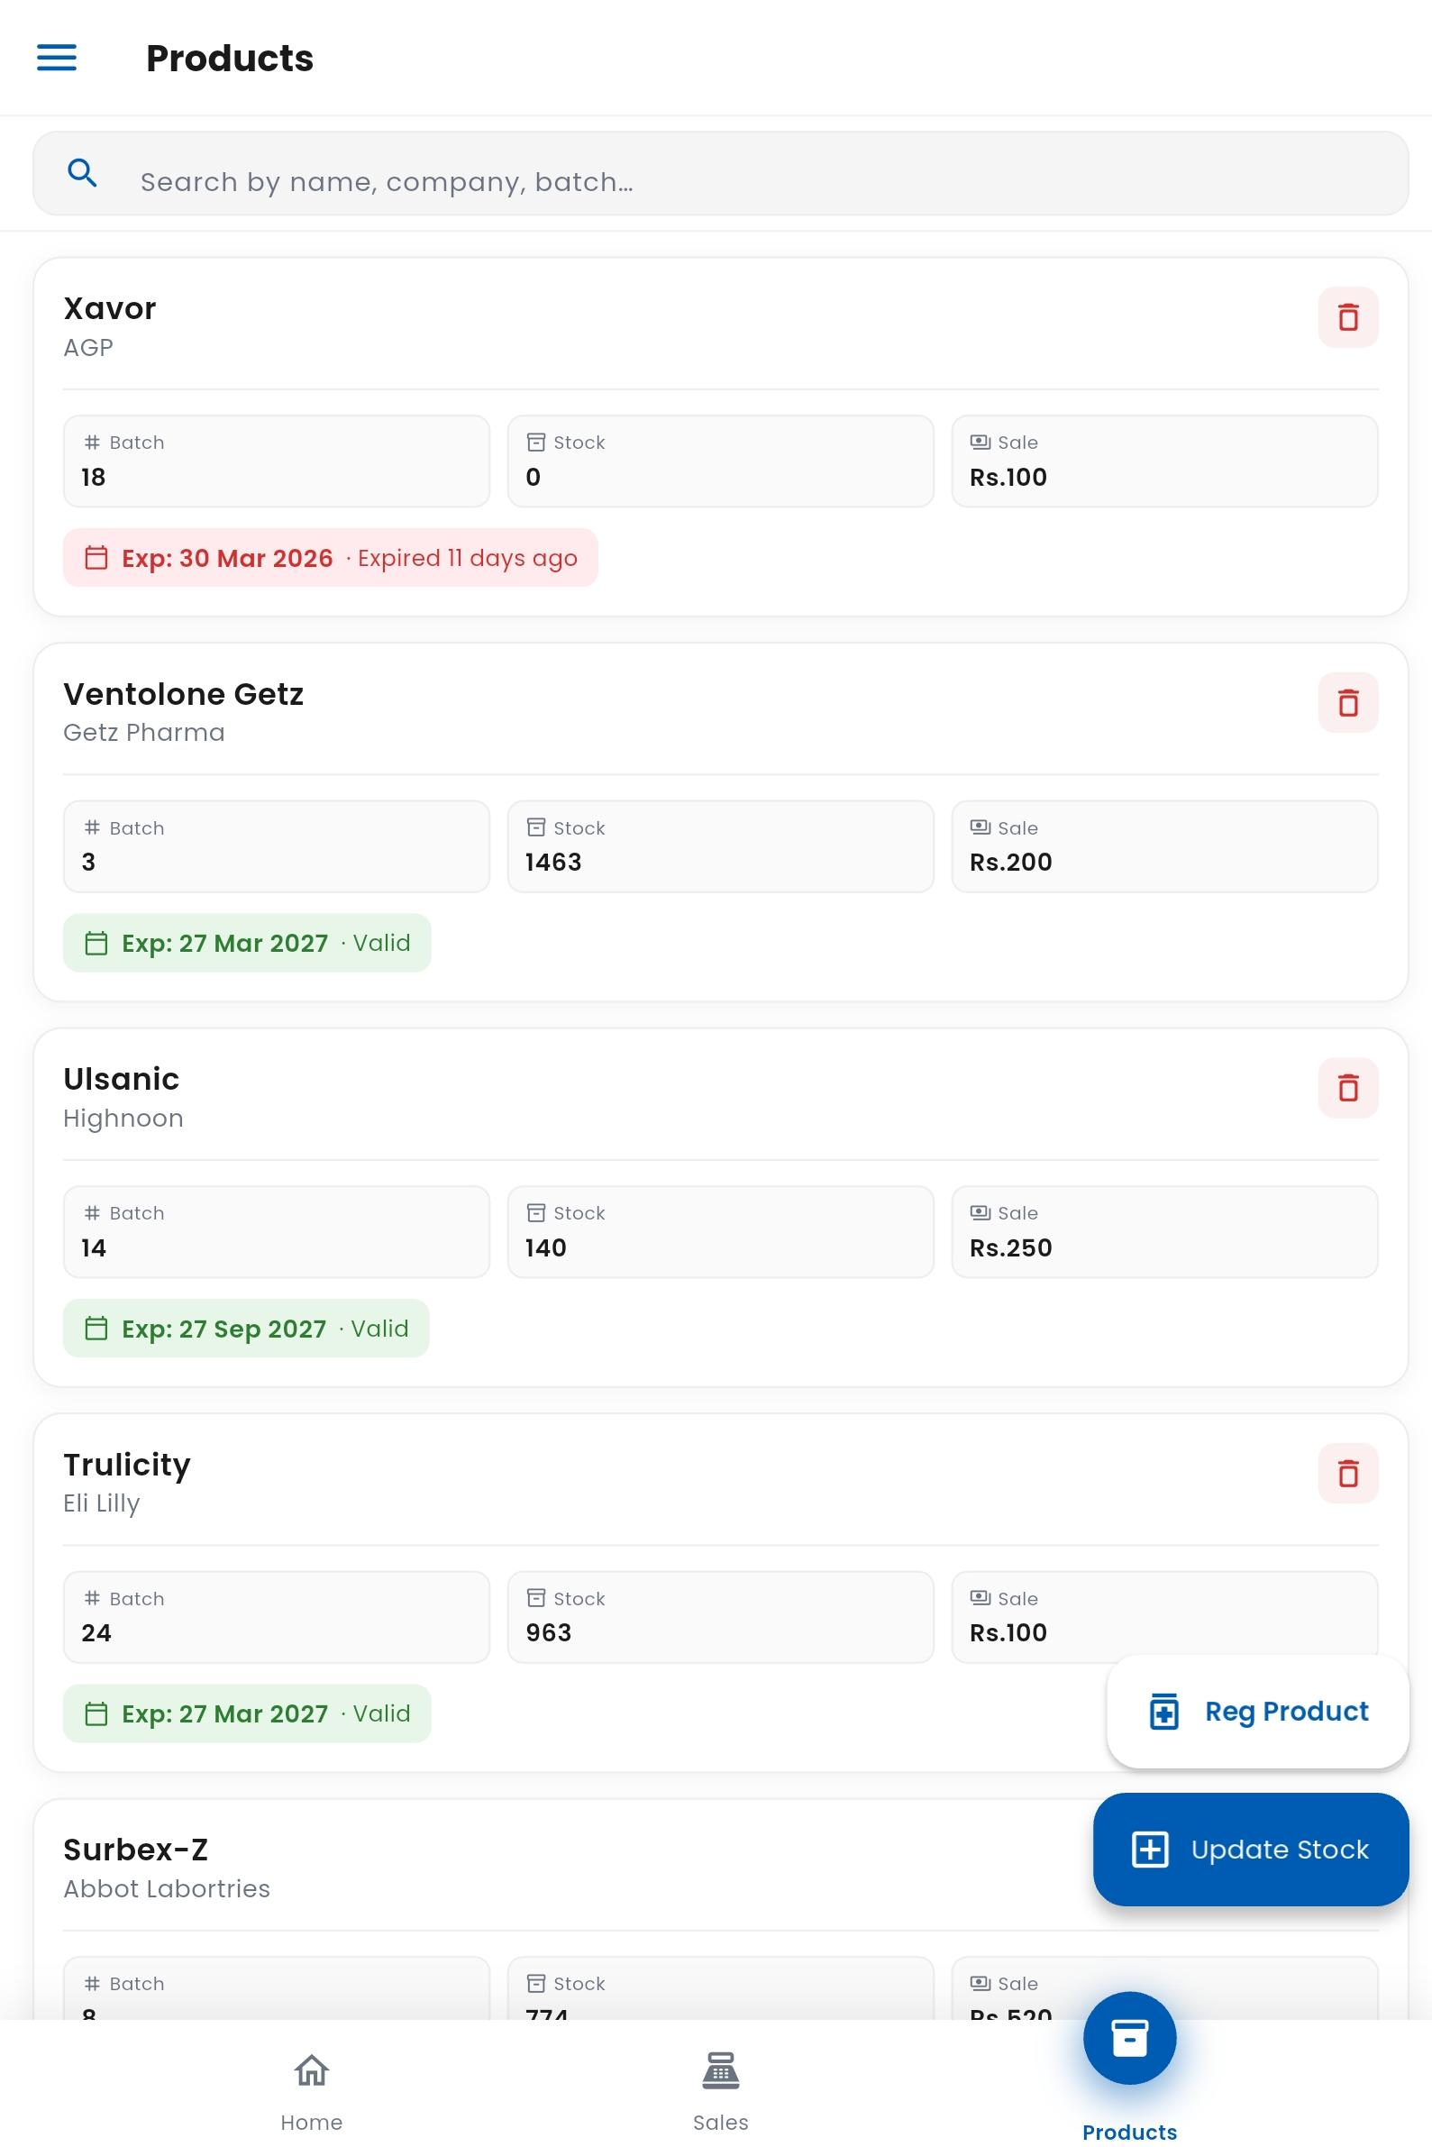

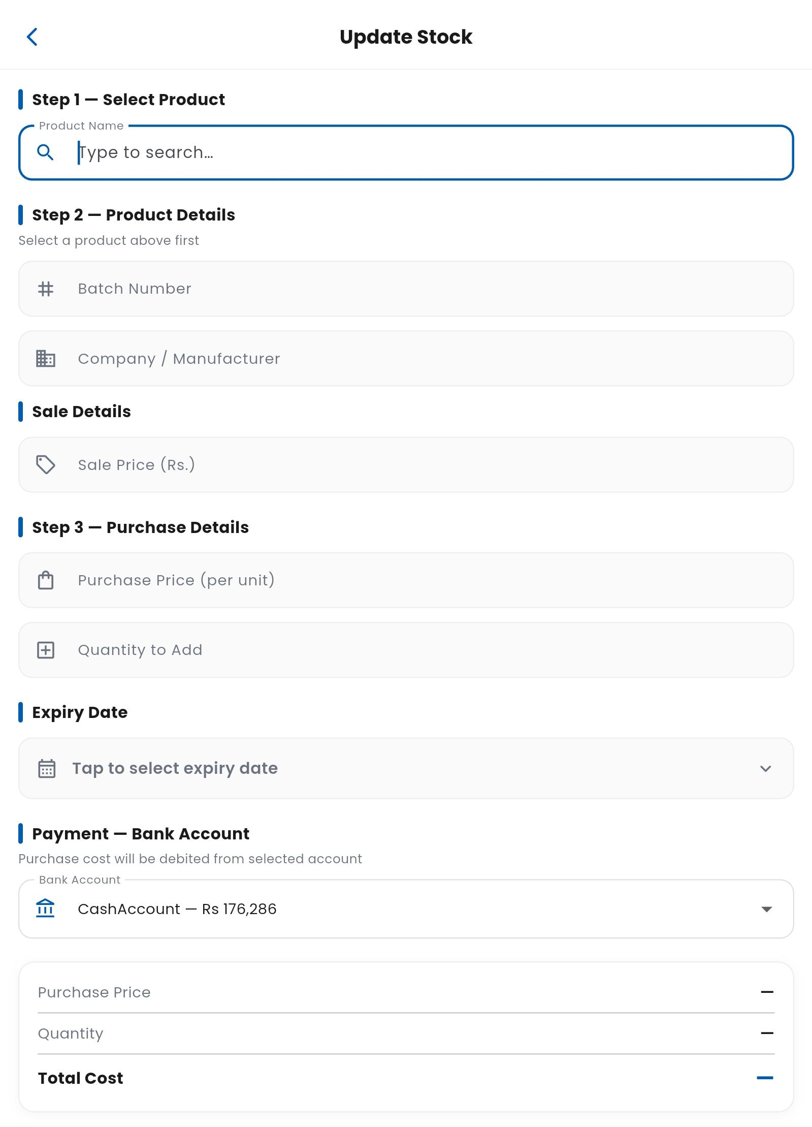

3. Sales Management
- Fast, keyboard-friendly sales interface
- Works without touch or mouse
- Add products to cart and process sales
- Discount options available
- Multiple payment methods:
  - Cash
  - Bank account
- Automatic bank transaction updates
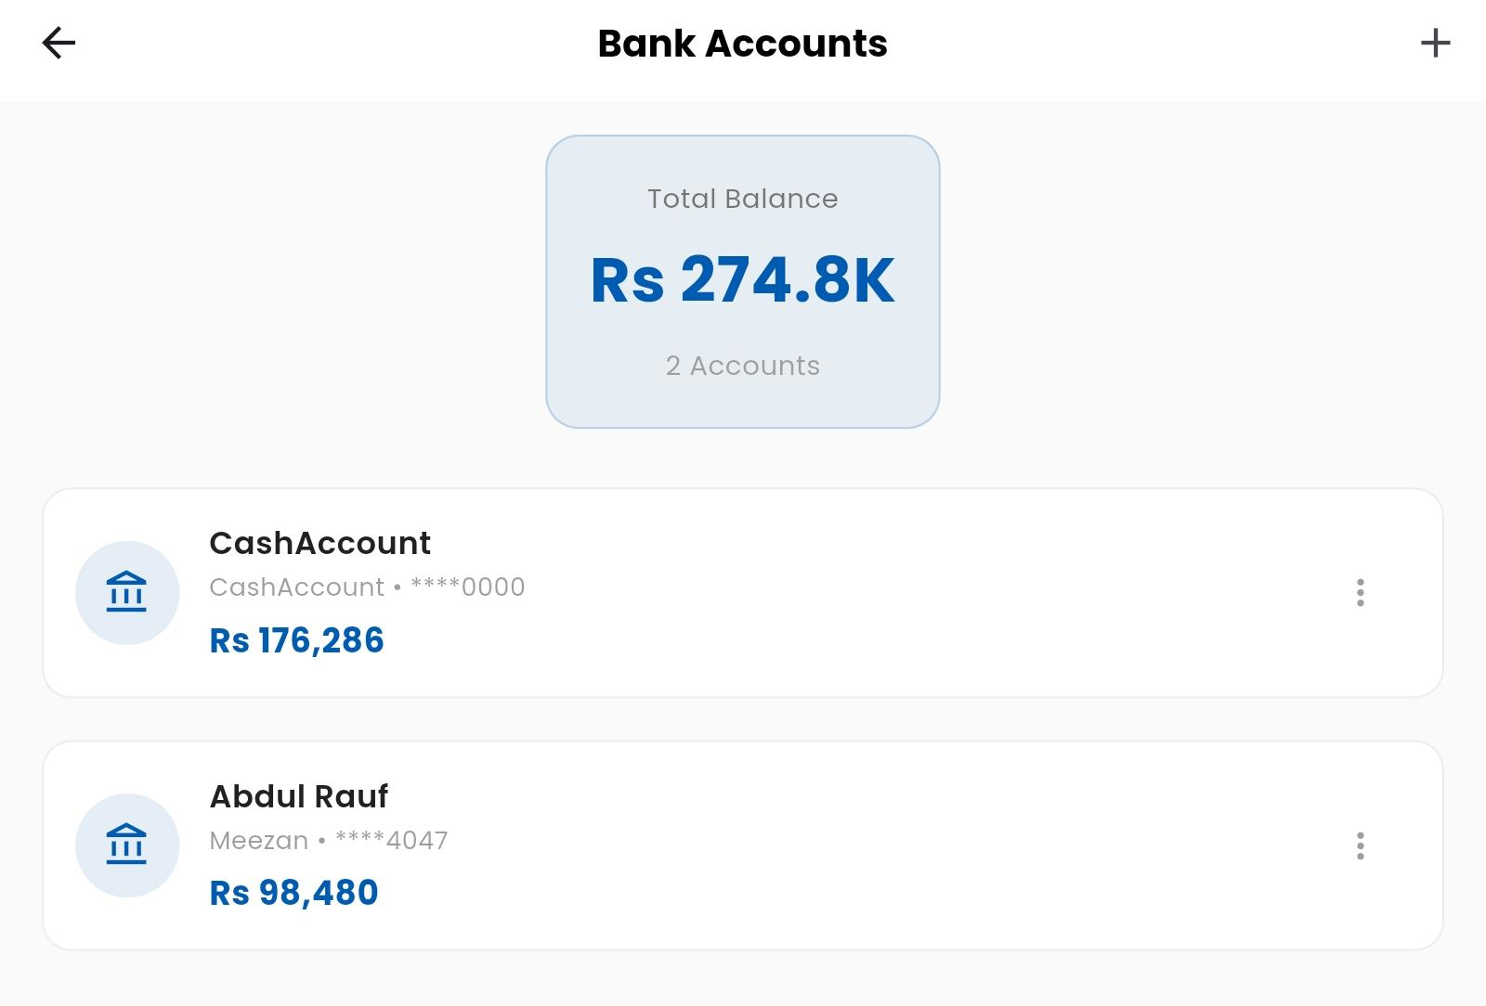

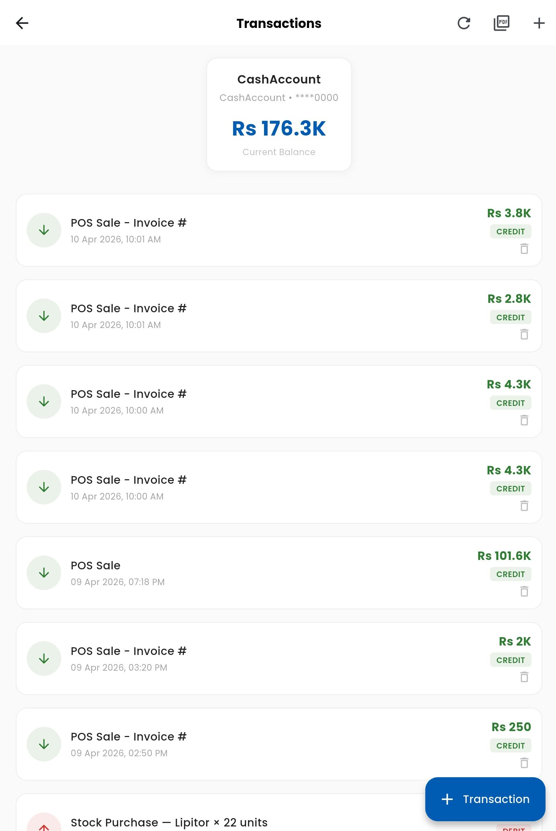
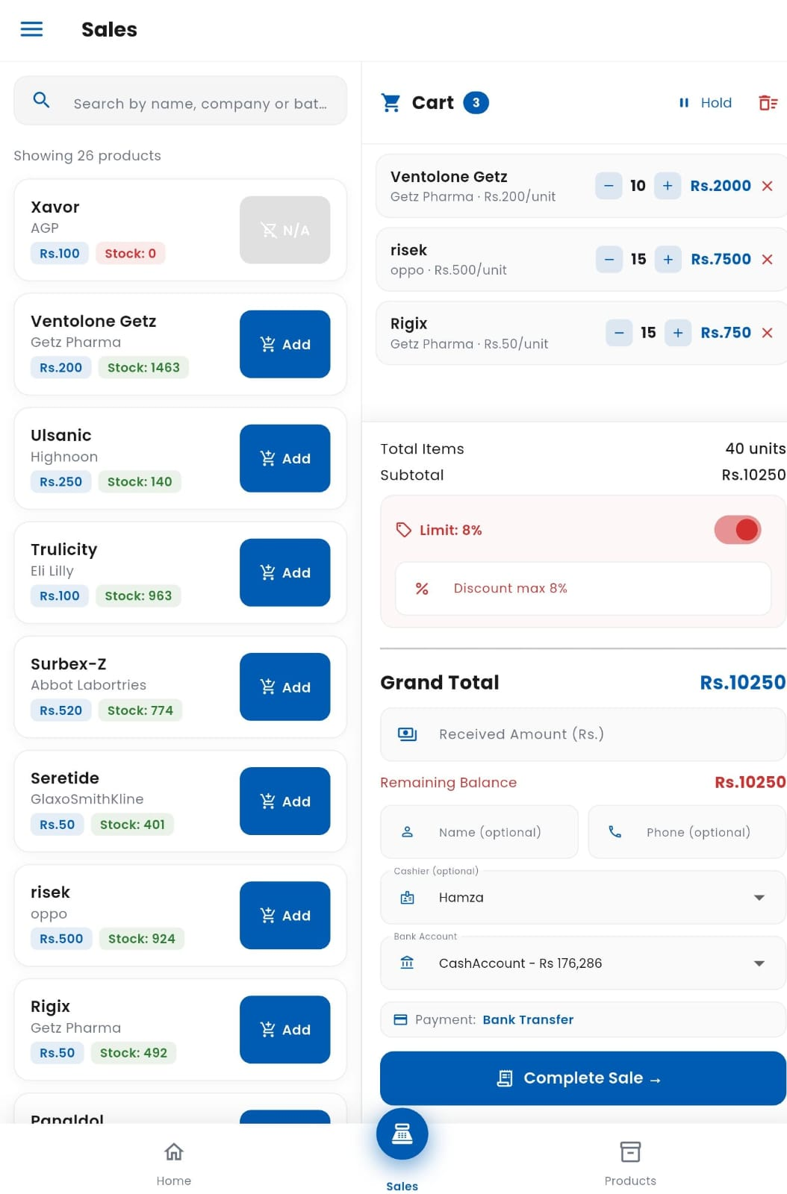

4. Invoice & Printing
- 80mm thermal receipt printing support
- Fully editable invoice format
- Reprint previous invoices

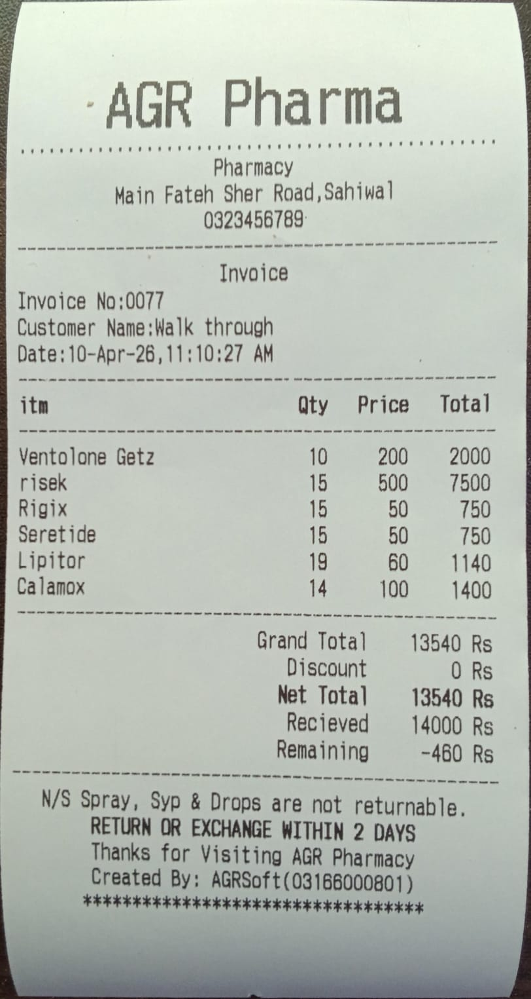

5. Customer Management
- Save customer with name and phone
- Customer ledger system
- Retrieve and reuse past invoices

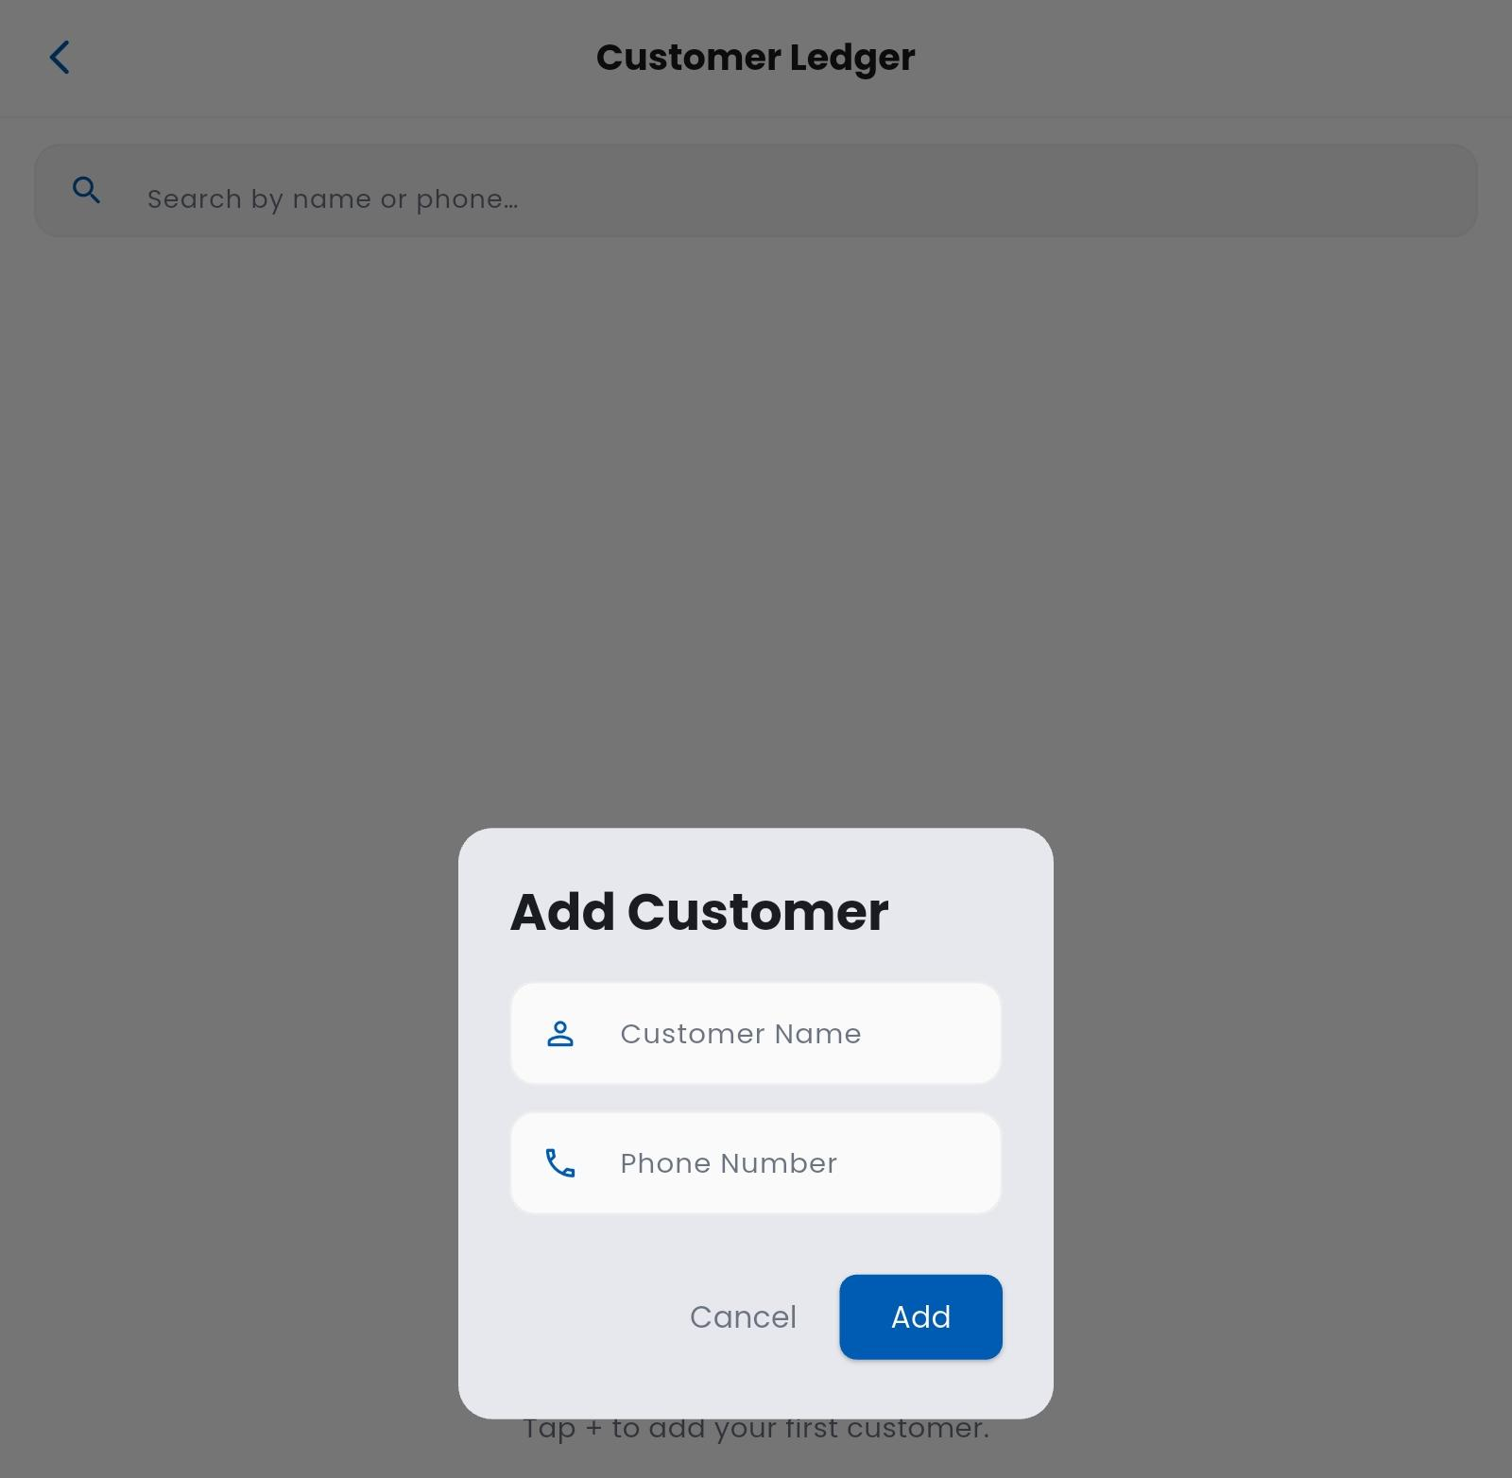
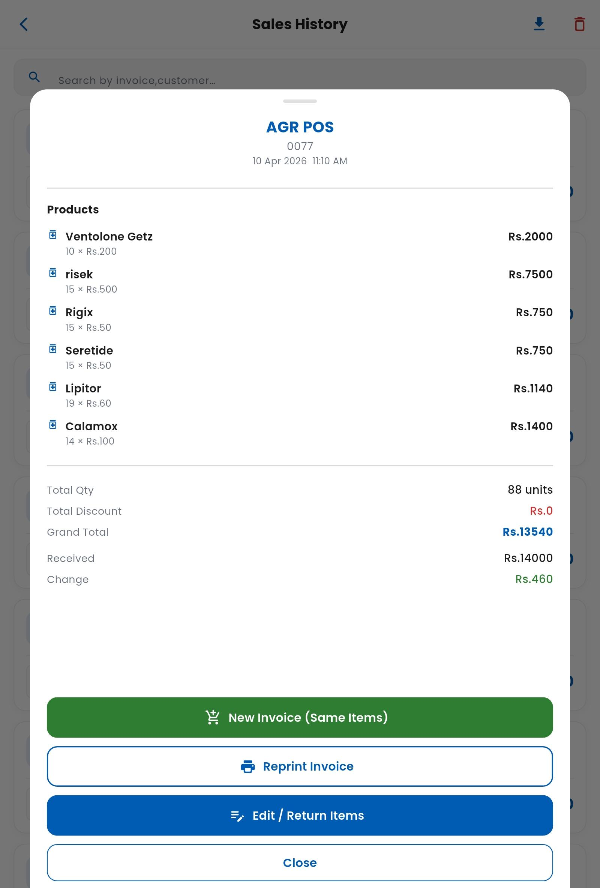
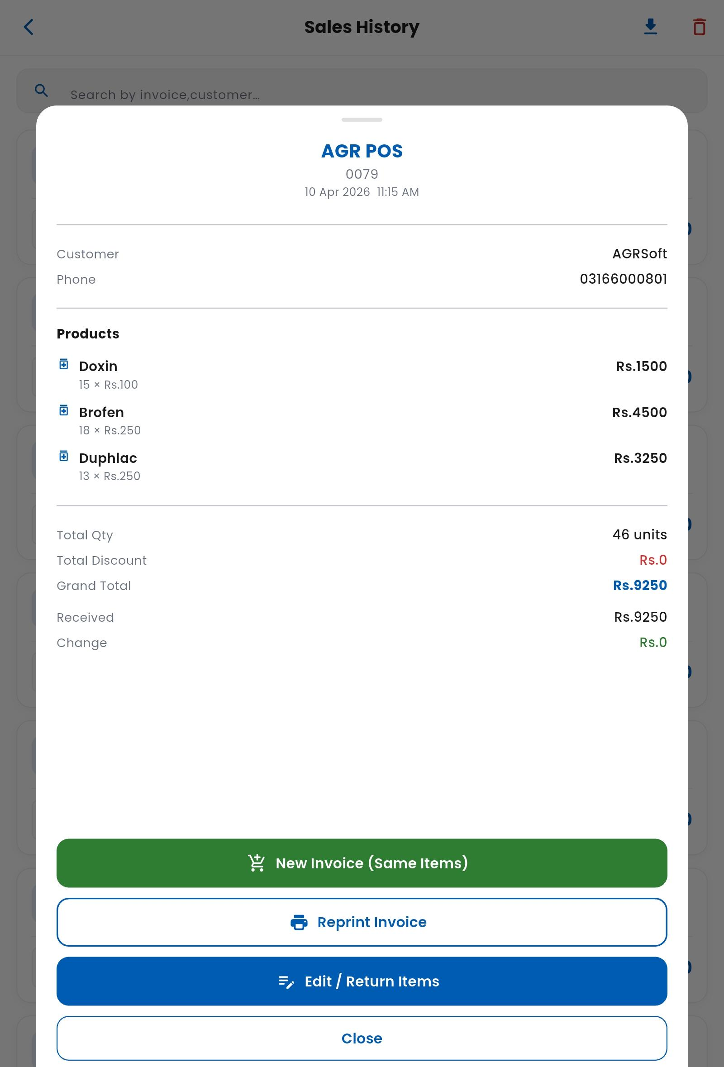

6. Sales History & Reporting
- Detailed sales history filters:
  - Daily, weekly, monthly, yearly, custom
- Export reports in CSV format
- Reuse past sales for quick billing
- Return and refund support with stock updates
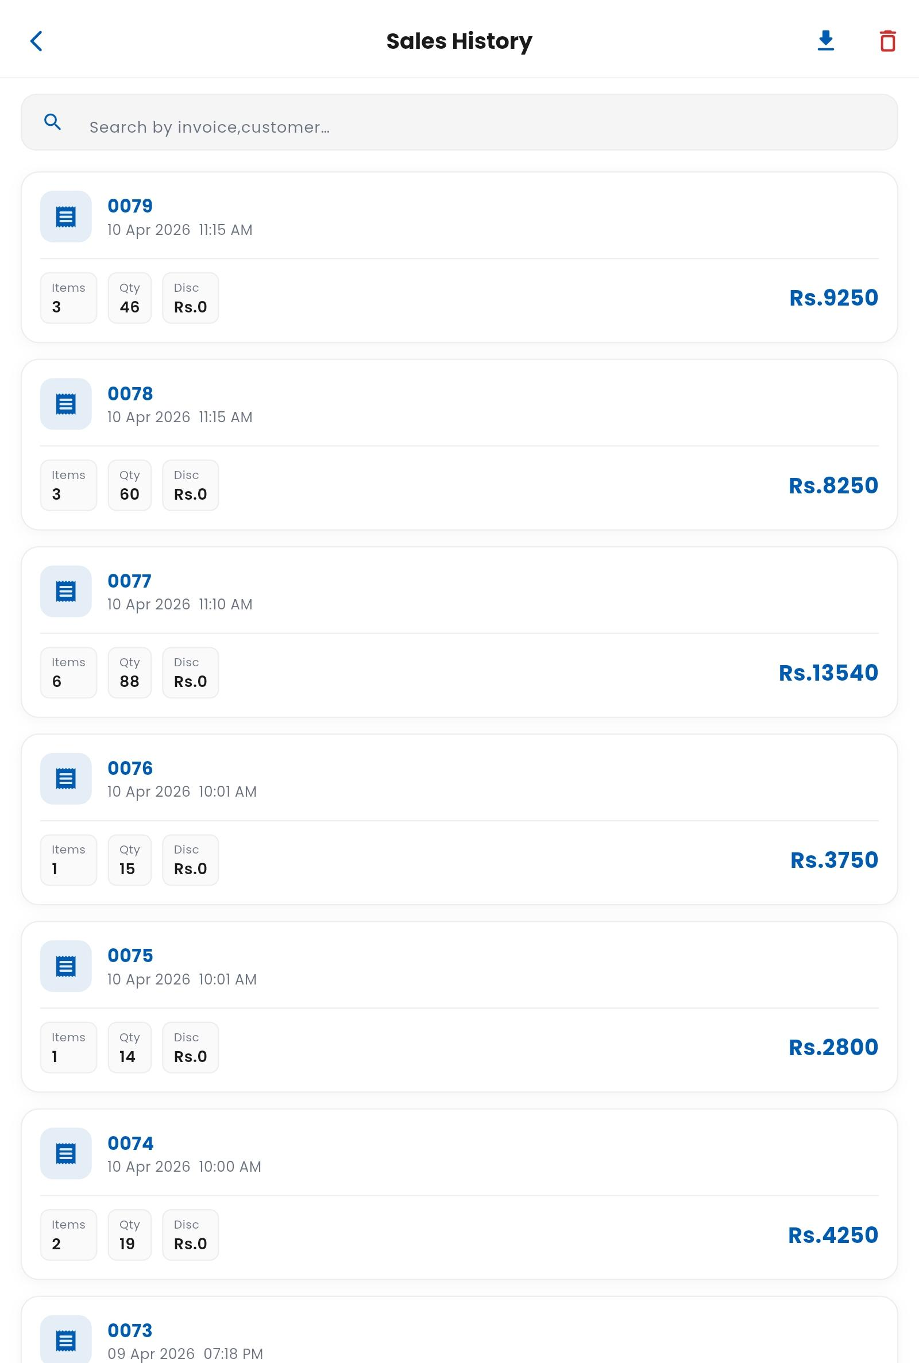

7. Financial Management
- Bank account management
- Automatic transaction recording
- Expense tracking
- Salary management
- Income tracking dashboard
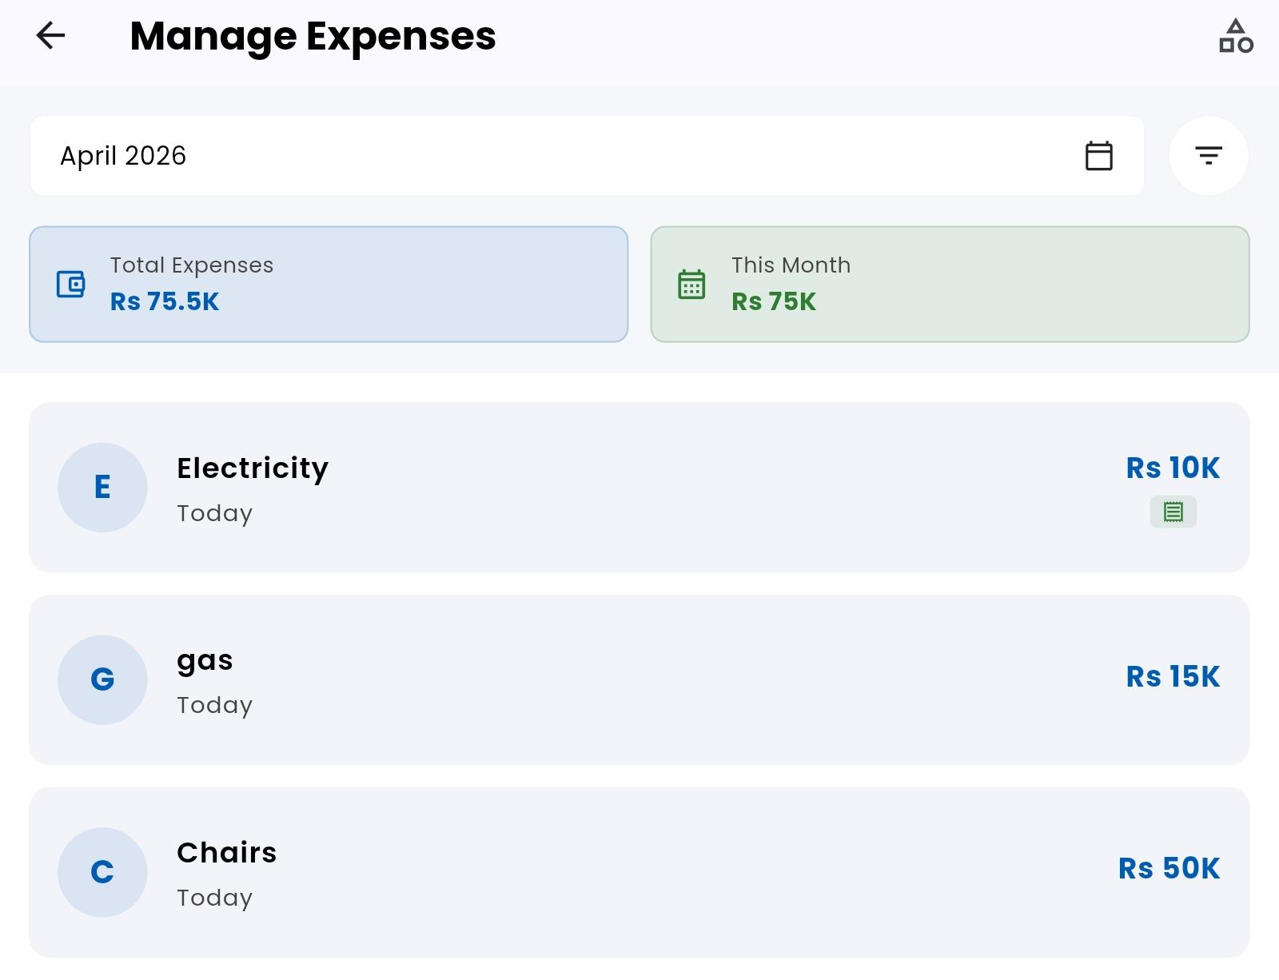
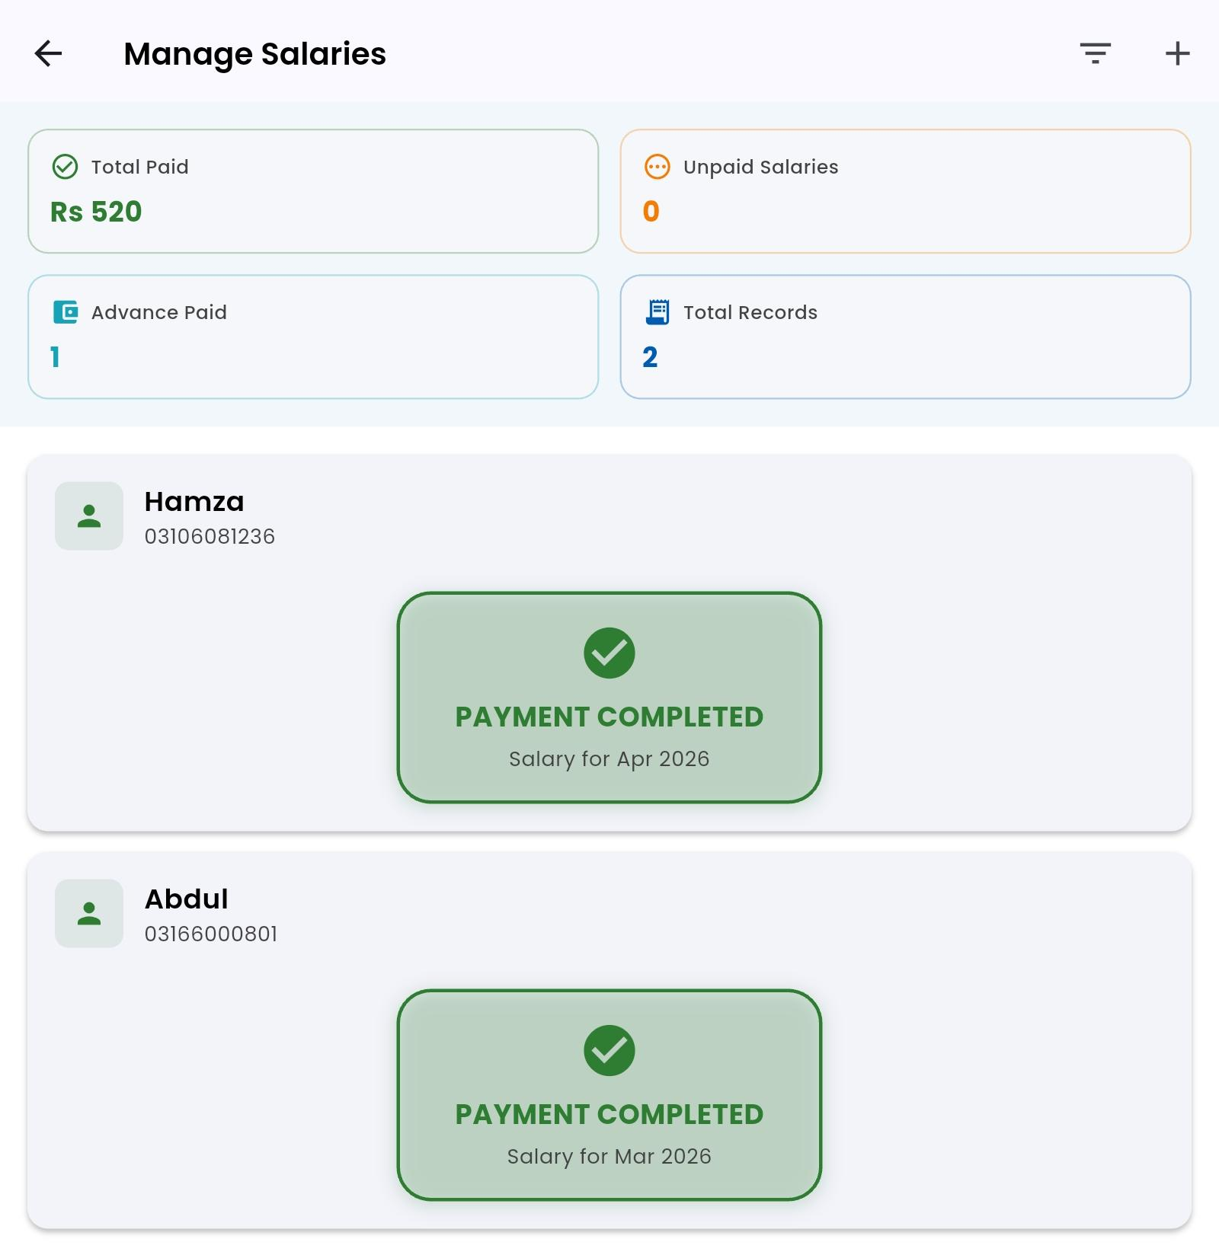
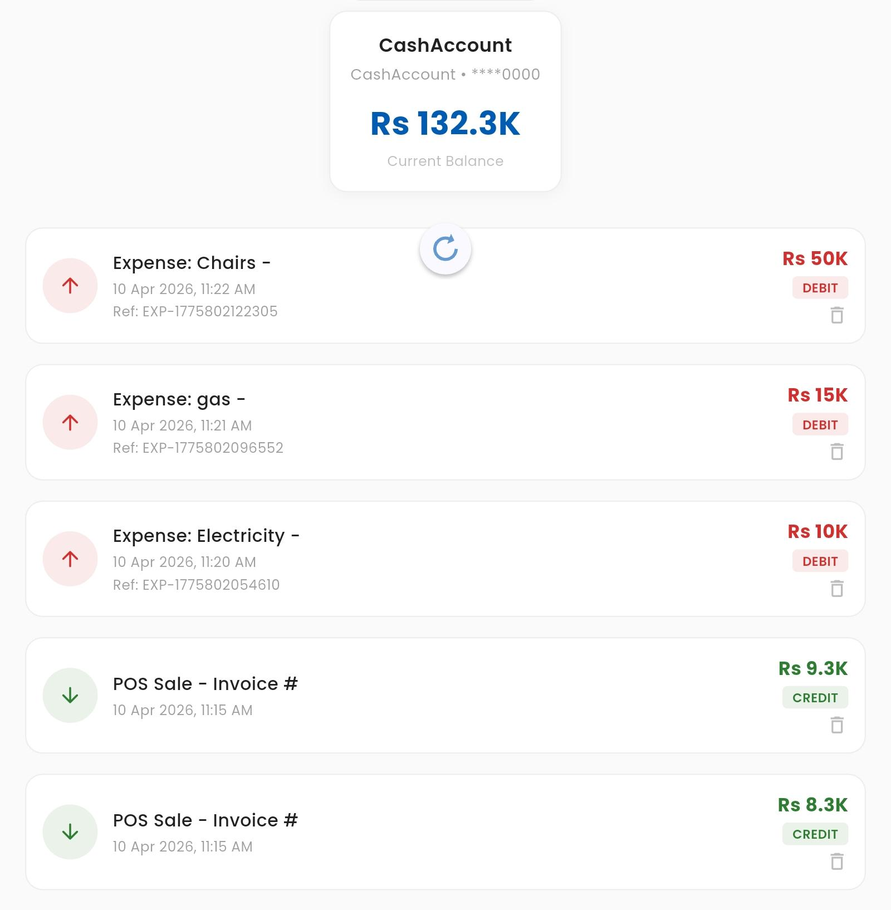
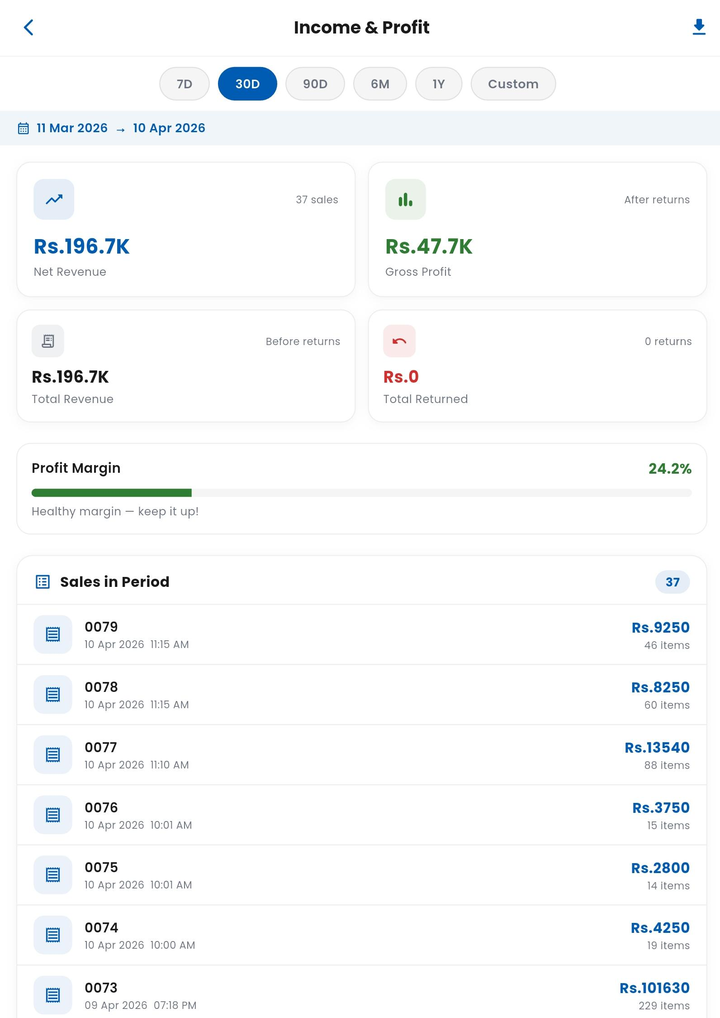

8. Dashboard & Analytics
- Sales overview (daily, weekly, monthly)
- Inventory alerts
- Profit graphical reports
- Exportable reports (CSV)
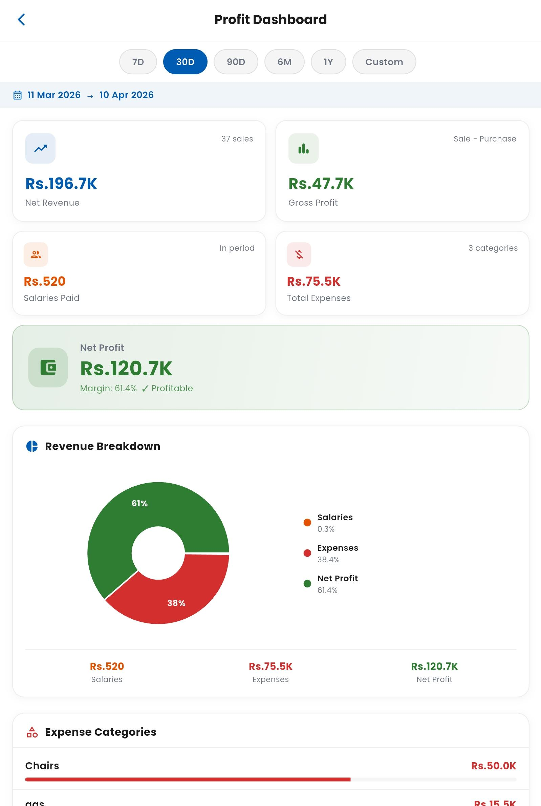

9. User & Staff Management
- Admin and manager roles
- Cashier management
- Employee records
- Salary tracking
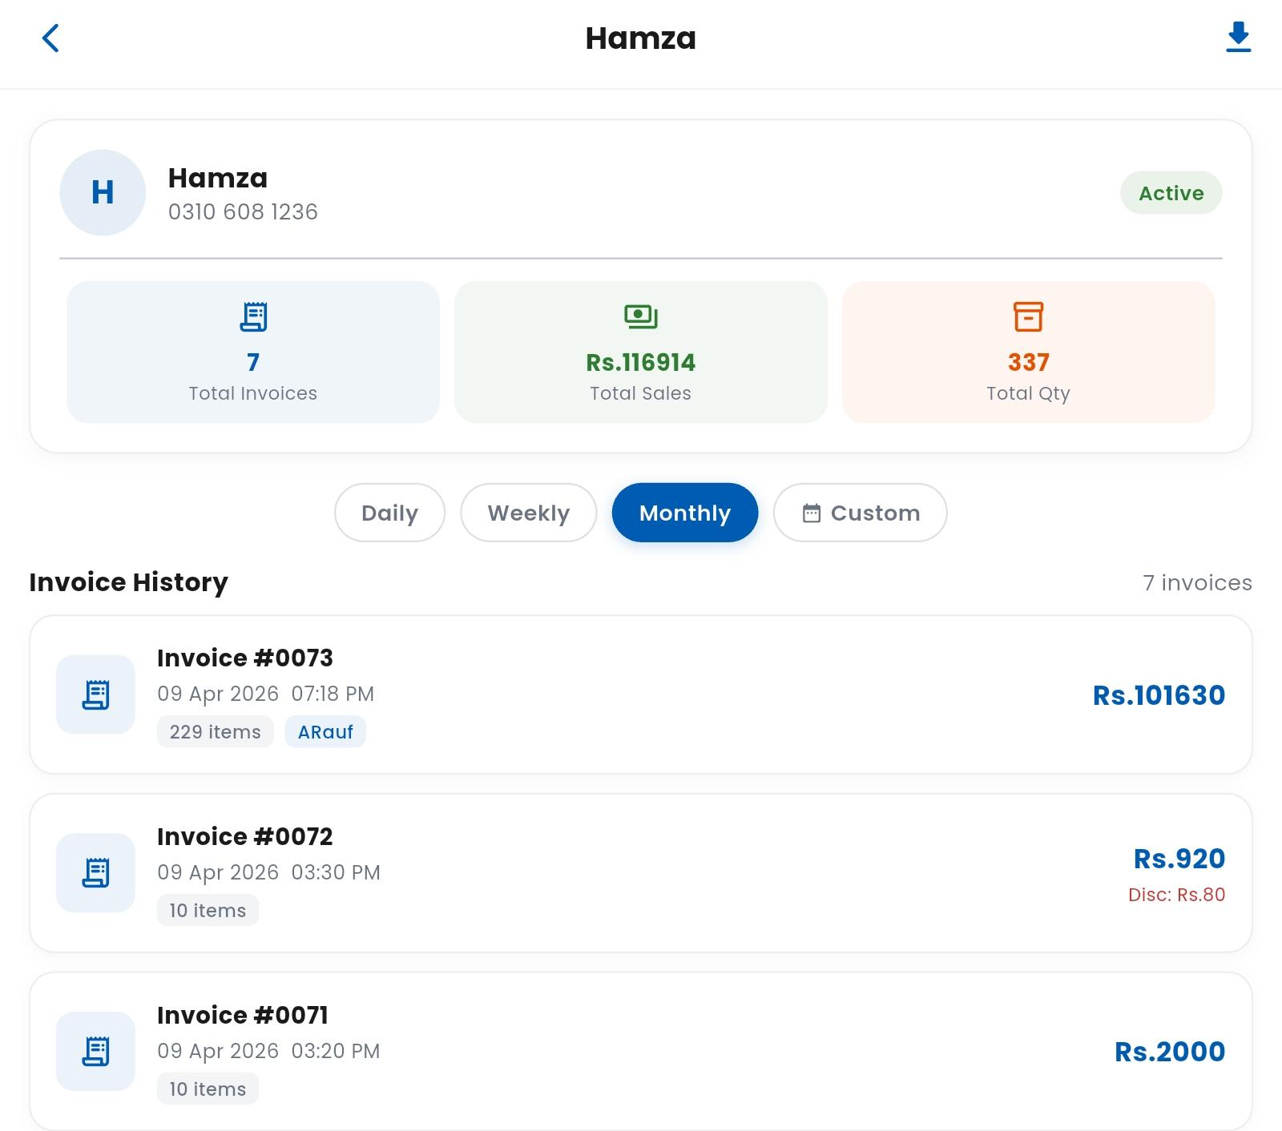
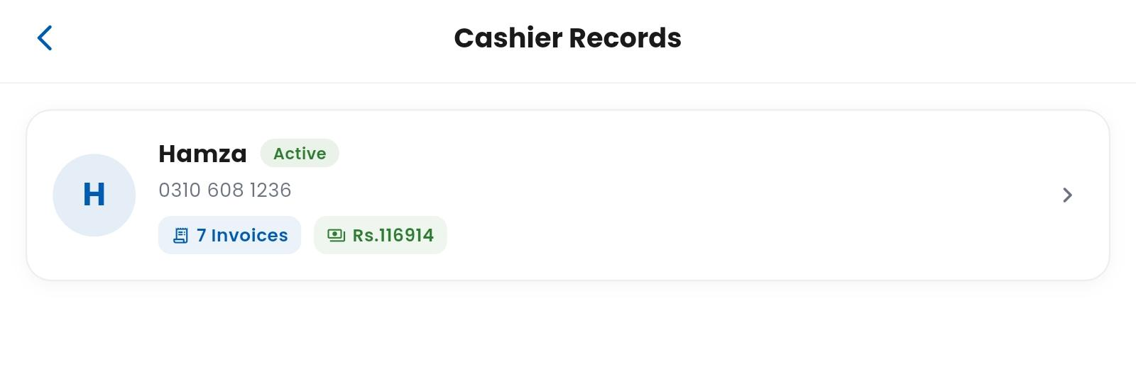

10. Audit & Security
- Audit trail system
- Track all deletions and updates
- Secure login/logout system

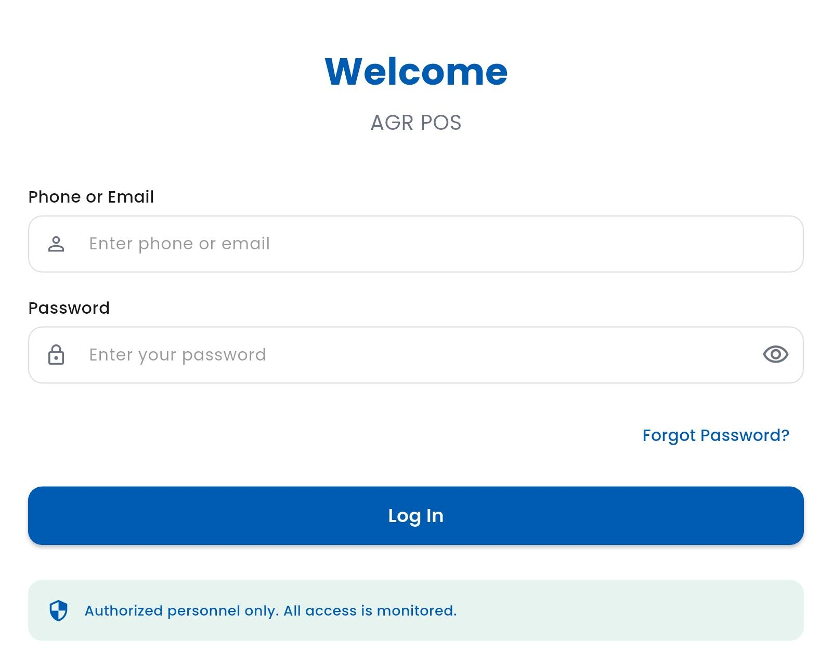

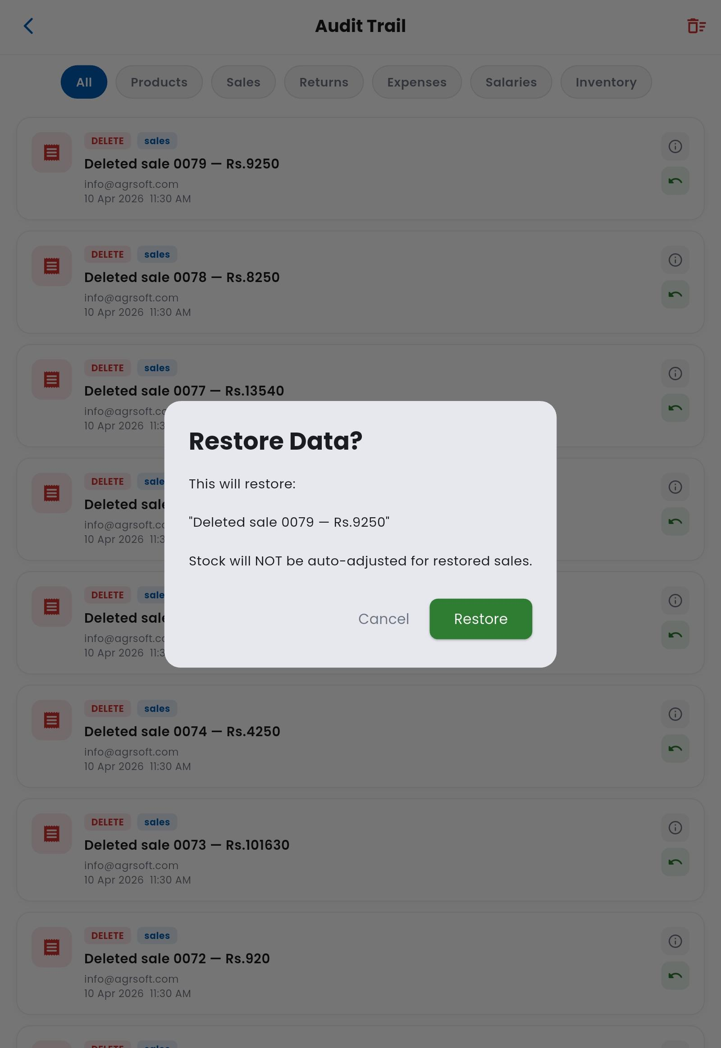

System Capabilities
- Cross-platform compatibility (Mobile, Tablet, Desktop)
- High performance and responsive UI
- Scalable architecture for business growth
- Reliable offline-first system
- On demand FBR POS integration is available

Summary
AGRSoft POS is an all-in-one business management solution combining inventory, sales, financial tracking, and reporting into a single, efficient system. It is designed for reliability, speed, and ease of use in both online and offline environments.

Version: 1.0.0
Developed by: AGRSoft Sahiwal
Email: info@agrsoft.com
Phone: 03100003289

